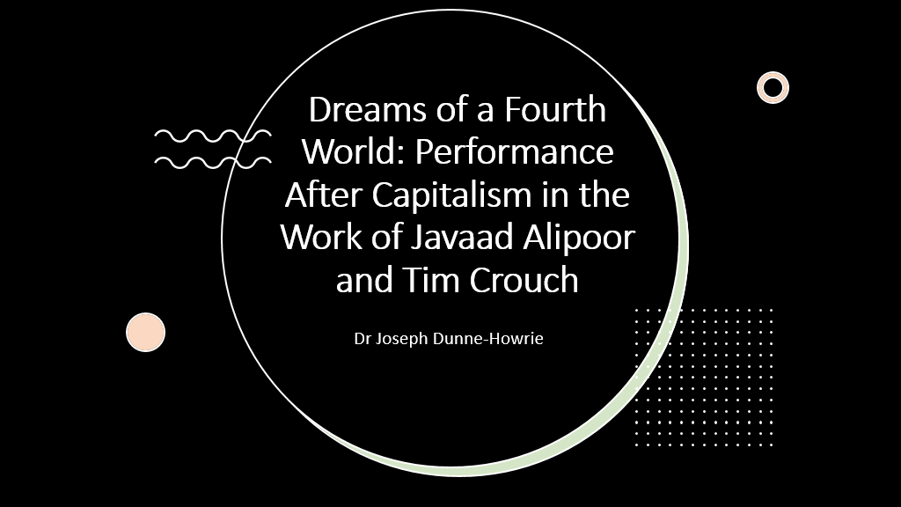
In writing this paper I realized the two performances I’m talking about don’t really do what I’m claiming in the abstract, so I’m taking a different approach to exploring how digital performance engages with postcapitalism. I’m drawing on several strands of my research into digital culture and networked audience participation, some of which are well developed, while other aspects intersect with my current investigations regarding performance’s contribution to culture war discourses, which are still in the early stages. This means that I’m not going to present a fully developed analysis but more a series of thoughts and provocations concerning the ways digital technology shapes theatrical narratives of postcapitalist futurity.
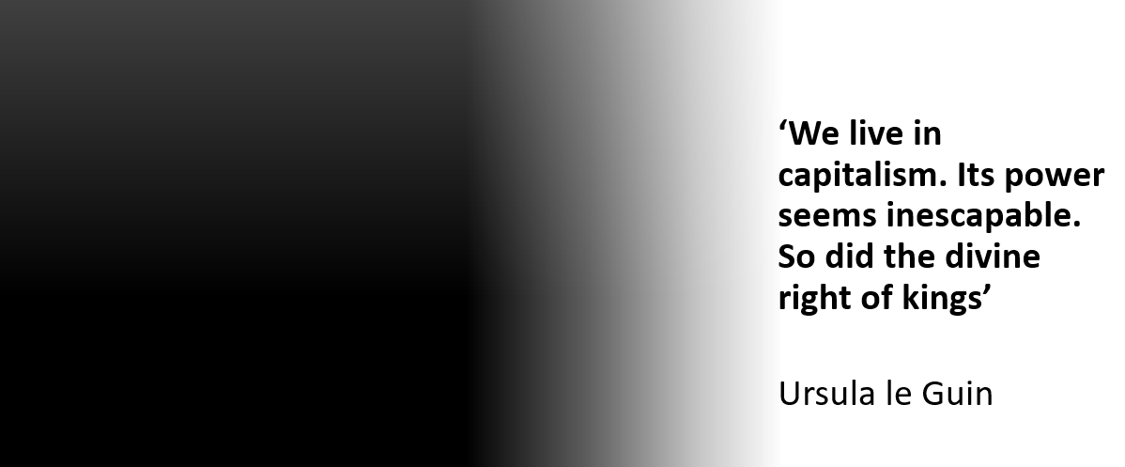
I am impatient for the future. I'm sure this is a feeling I share with many in the room. Living in an age of ecological breakdown, political extremism, and economic precarity makes vicarious forms of existence highly appealing. I find myself deferring my commitment to living in the present by treating it as preparation for the time that will, surely, come soon, or at some point, when capitalism ends.
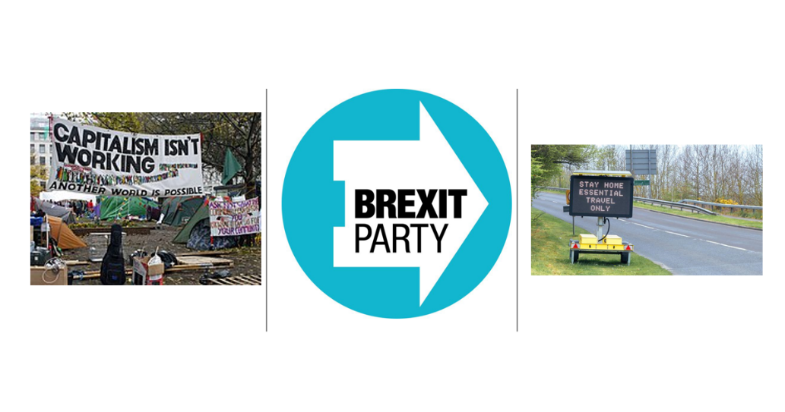
And yet I find myself asking if the upheaval of the past two decades was in fact the end and we've somehow missed it. Not the end of capitalism per se, but of the future it once promised. Economic exploitation, the corporate capture of the public realm and hyper-individualism are not things of the past. The injustices of capitalism have not been overcome. What makes the present historical conjuncture unusual is the failure to produce visions of futures that are configured by the desires, hopes and dreams of the contemporary real. The curtain has fallen on the pre-ordained future of neoliberalism, but we continue to act as spectators to a world that has ended. We are continuing to experience the ending of this political system as a permacrisis yet remain fixated by the spectacle of catastrophe that surrounds us. The absence of alternative ways of living forces us to recycle images of previous revolutions in a vain search to identify what fundamental societal change looks like and will look like again.

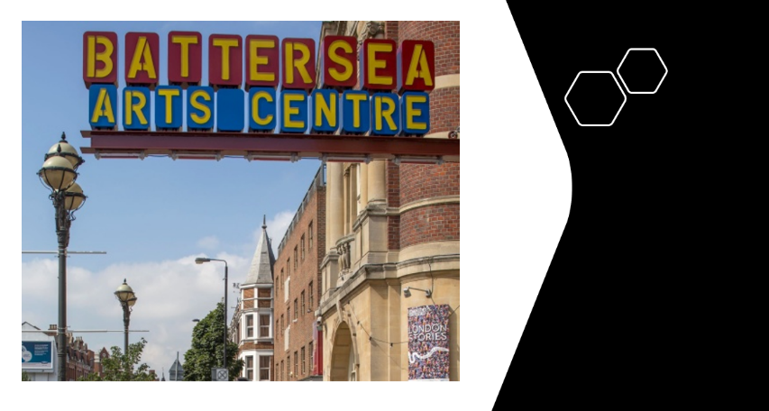
The two pieces I am discussing today were both performed at Battersea Arts Centre in Southwest London. BAC represents for me the crucible of artistic experimentation and social utility I ache to see becoming a model for all public institutions in a time we can choose to call postcapitalist. The materiality of this former town hall evokes memories of civic life that Thatcherite ideology has corroded for over forty years. Combined with its policies of pay what you can, disabled access, and relaxed performances, BAC works against the grain of the normative consumerist mentality. Equally, acting as a home for new and emerging artists allows BAC to catalyze a radical political imagination with new generations of activists and artists distinct from the socialist movements of the twentieth century. Whilst working in very different contexts, Edward Bond and live artist Tania El Khoury separately argued during the thick of the pandemic that a sickness had taken root in the theatre industry resulting from the free market entering the most intimate corners of our personal and professional lives. 'A crisis is a situation that can't be resolved within the situation where it occurs' writes Bond. 'That means that society is confronted by itself not by any particular happening within it'. Theatre, for Bond, is a site to practice democratic life by confronting reality with fellow citizens. For El Khoury, democratic agency can be actualized in performance by inviting spectators to question their positionality in relation to the work and to each other in the space.

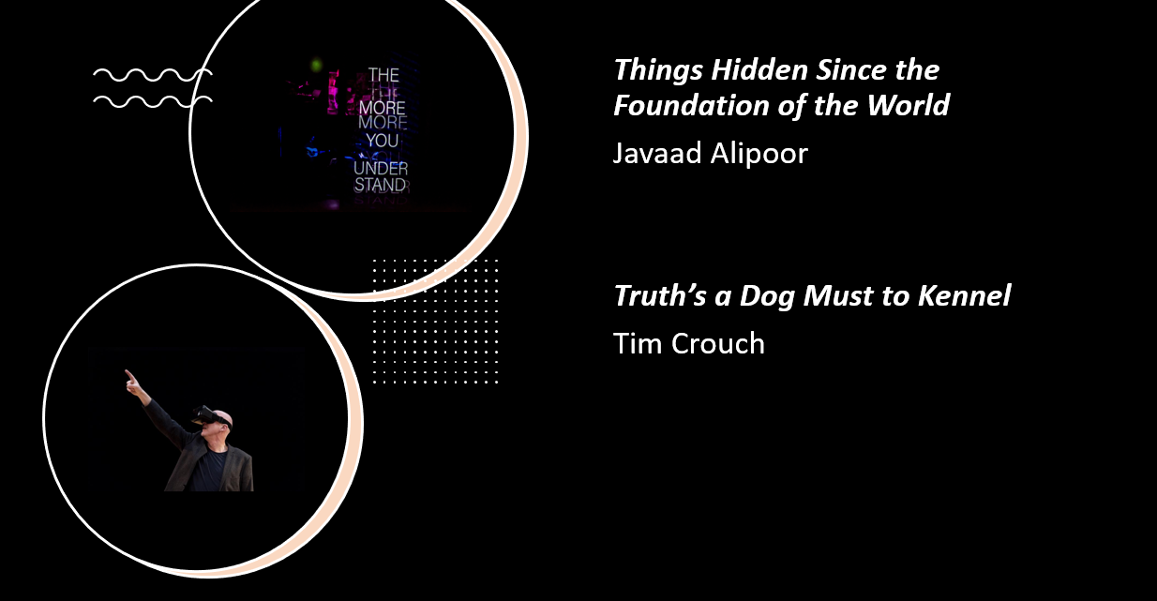

I'm interested in the contribution that the materiality of digital performance practices makes to this discourse of postcapitalism. I'm approaching this topic from two perspectives. Firstly, I wish to understand how theatre-makers who work in intermedial contexts contribute to building radical worldviews through the interaction between corporeal and technological entities in performance. Intermedial dramaturgy makes visible the spaces between the technological materials and processes that are embedded which, Joanne Scott suggests, creates 'a productive unease at the otherness of such processes in…everyday existence’ (Scott 2020, 147). I consider this unease to have a political value in its capacity to unsettle audiences out of familiar patterns of thinking as the first step in making a postcapitalist future an indeterminate engagement with otherness in multiple contexts and settings. This leads me to discuss the potential of digital performance aesthetics to act as the conceptual architecture for the kinds of political cultures Bond and El Khoury refer to in relation to Javaad Alipoor's Things Hidden Since the Foundation of the World. The combination of intermedial, metatextual, and documentary forms in the piece frames online interactivity as a metaphor for the imperceptible interplay of global historical forces that bring about radical political change. Alipoor's explicit positioning of theatre as a space to practice civic antagonism locates digital performance as one part of a networked discourse regarding the coercive threats and liberatory potentials technological advances represent for democracy's future. In contrast, the second theme of this paper concerns the ostensive threats technological mediation poses to live performance's ontology as explored in Truth's A Dog Must To Kennel. Virtual reality is treated as a parasite in the immune system of collective imagining between actors and spectators that is so fundamental to Crouch's work. What sets these two pieces apart is their use, or provocative non-use in Crouch's case, of intermedial aesthetics to create ideological representation of postcapitalism. I see these differences as illustrative of an essentialist attitude towards theatre's identity from artists like Crouch, who see technological innovations as tools for social atomization and theatre as a place of refuge from machines.

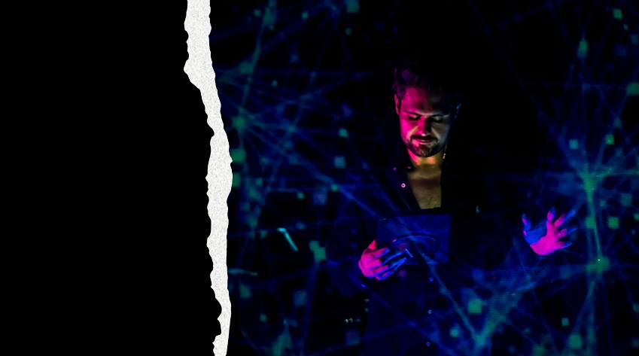

Screen clipping taken: 18/08/2023 12:41

Things Hidden Since the Foundation of the World interrogates how the epistemology of liberal humanism continues to shape western audiences' understanding of the legacy and colonialism in the Global South. The show's dramaturgy emulates an Internet deep dive by interweaving a fictional true crime podcast series and a meta-theatrical meditation on subaltern knowledge. The podcast investigates the real-life murder of 1970s Iranian pop sensation Fereydoun Farrokhzad, which is refracted through a fictional crime podcast investigating the murder and the autobiographical tale of Iranian-Canadian singer King Raam (whose real name is Raam Emami). The podcast is framed as a media format that, much like the nineteenth century novel, is inscribed with the assimilationist trope of liberalism in its reliance on translating otherness using cultural references immediately familiar to Western ears. Describing Farrokhzad as the “Iranian Tom Jones” immediately gave the audience a model to base our interpretation of his cultural significance on Iranian society upon, but modelling our understanding of his murder within a knowledge domain utterly disconnected from the reality of the political context Farrokhzad lived within brought us no closer to seeing the discursive territory his life as an artist and political exile originates from. The space between knowledge and understanding is called the “void” in the performance, expressed by King Raam as subaltern knowledge, which he experiences as the space that exists between “the world you want to live in and the world you are forced to live in.” Subaltern knowledge is generated from the politics that occurs beyond the gaze of what Stuart Hall calls the “panoptic, universalist eye” (Hall 55) of Enlightenment conceptions of civilizational progress. The attempt to bridge the void between Iranian and British cultures through a podcast illustrates how the futurity of liberal, free market capitalism is bound to the production of objects that will outlast humanity. The refusal, or even impossibility, of King Raam articulating his experiences as a political exile living between west and east in a logocentric narrative is juxtaposed against the surety of the podcast host's wild theories about Farrokhzad's murder. Alipoor frames subaltern knowledge as amorphous network intelligence that cannot be instrumentalized in the capitalist machine of technological assimilation and control. The intangibility of this knowledge forces us to work beyond cognitive interpretation if we are to see, not understand, otherness. In this sense, subaltern knowledge embodies what the art critic Boris Groys describes as the flow of digital culture. The intermediality of Things Hidden puts the audiences into a flow of narratives that we struggle to connect. It stages the process of interpretation, contemplation, and analysis of western epistemologies depend on to bring otherness within a knowledge domain we understand. In Things Hidden, the image must precede the word, for it is in language that the otherness becomes commodified into the object. The sense of chaotic multiplicity we experience through networked interaction is the precursor to creating images for a postcapitalist future. King Raam embodies a kind of information vector that is inaccessible to Western audiences without his presence, someone from a subaltern community who cannot bring the world they are from to a Western audience and who cannot take them to that world. Learning what these differences are without technological filters and hackneyed cultural metaphors requires what he calls a “different kind of understanding.” This is not about understanding the world as it really is through objective reporting or cultural analogies, but making the hidden political struggles that bring about real change visible through performance.
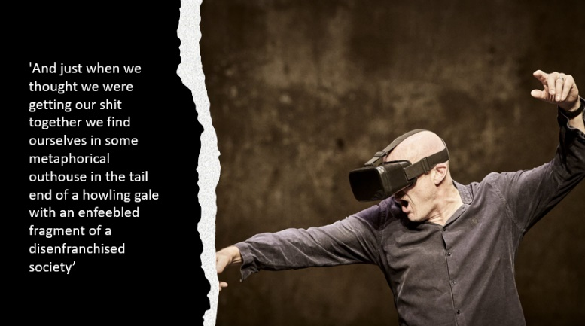
The flow is hell for Tim Crouch. Devoid of imagination, danger, truth, or beauty, it must be resisted if theatre is to survive. Truth's a Dog Must to Kennel is a delphic and often frustrating play about the communalism of live performance being effaced by virtual reality. The only postcapitalist theatre worth fighting for is one that is free of technology, or at least one where theatre can act as a humanizing refuge from the wired world so artists such may dream their dream into another's head. I situate the play in the historical context of globalized financial capital becoming hegemonic in the post-Cold War period. For people like Michael Kustow, author of theatre@risk, the Internet was thought of as an instrument of controlling bodies and replacing embodiment with simulation. The homologous futurity of human agency becoming operationalized to the logics of the free market became a point of resistance for the global left in this period. Crouch positions live performance in opposition to this future, which for Crouch is the cause of today’s societal alienation leading to audiences withdrawing into individual consumerist experiences found online. Truth's A Dog uses a virtual performance of King Lear as an analogy for the crisis of democratic capitalism. The worlds of Lear and contemporary democracy are violently unravelling, ripped apart as old certainties are obliterated before our eyes. Crouch explores this from the perspective of the Fool who finds himself taken out of the virtual realm into the live space of the auditorium as a stand-up comic. The performance begins with Crouch describing a fictional virtual audience in the live auditorium as wanders about the stage wearing an empty VR headset. He pokes fun at theatre conventions like ordering pre-show drinks in a warm if rather sentimental speech intended to make VR's individualist format accessible in dialogue. Crouch's argument that VR and other digital technology renders citizens isolated and impotent in the face of societal collapse is prefaced on the false dichotomy between the corporeal and the virtual realms where embodied presence signifies the difference between reality and simulation. Further, I see this attempt to render the virtual world present in text as an example of the kind of logocentric knowing critiqued by Alipoor. A void exists between the live audience and the imagined one which in Crouch's dramaturgy can only be bridged by the interlocutor of the actor. Victoria Scrimer describes this centering of the white male voice as 'scriptocentrism', the 'aesthetics of truth' western audiences have become inculcated to see as the ultimate authority (2022, 129). The patriarchal resonances of this set-up are enhanced in later speech when Crouch describes live performance as a funeral conducted in a language that 'no-one speaks anymore' (15). The live audience are invited to mourn for a time when we could participate in the dreaming of worlds together as we sat in the dark in silence guided by the wise hand of the playwright. It's important to point out that the interrogation of language's limits in Things Hidden mitigates against this logocentric argument, but it's notable that Alipoor also performs as himself to reveal make these limits visible. Truth's a Dog and Things Hidden self-consciously perform the practice of evoking worlds in the margins that digital technology is unable to make fully present to us. These pieces can be considered digital postcapitalist performances through their disavowal of narrative online consumption in favor of communal and even collaborative artistic experiences. Yet what neither succeeds in doing is creating a postcapitalist aesthetics to give this futurity a concrete form.
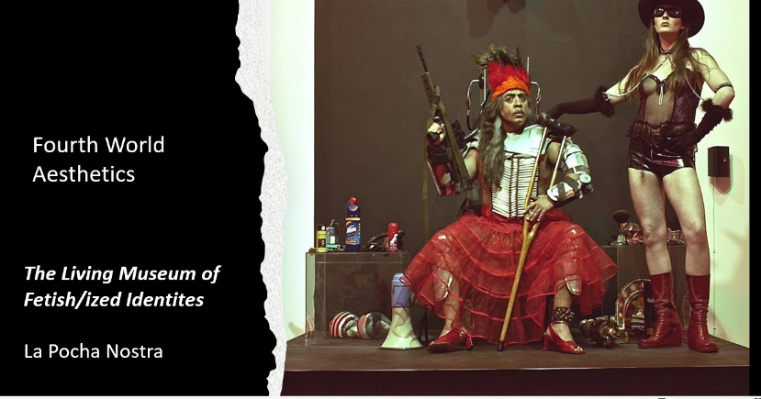

I'd like to conclude by suggesting that Fourth World aesthetics as conceptualized by Jennifer Ponce de Leon in Another Aesthetics Is Possible gives us glimpses of what postcapitalist performance may constitute. Ponce de Leon's theory is not situated in a digital context, but the emphasis she places on transcultural hybridity resonates with discourses of interconnectivity and hybridity associated with digital culture. The 4th World War was coined by the Zapatistas to describe globalized capital and logics of the market coming to dominate all forms of human existence following the end of the Cold War in the early 1990s. The Zapatistas are a Mexican far-left militant group who declared war on the Mexican government following the signing of the North American Free Trade Agreement on January 1, 1994. For many on the left, NAFTA continues to encapsulate the erosion of democratic rights in its disenfranchisement of indigenous communities and labour movements through the liberalization of global trade. In a broader sense, NAFTA represents the triumph of the free market over socialism. The loss of faith in alternative any alternative historical teleology to global capitalism coinciding with the proliferation of the Internet provides the context for understanding why the digital revolution was considered an assault on theatre’s ontology in the 1990s. Fourth world aesthetics seeks to expand the concept of globalization beyond an economic context by imagining how systems of interconnectivity can upend, disrupt, dismantle, and reinvent the Eurocentric determinacy of race, nation, and ethnicity, all of which are mediated by capitalist systems of consumption, commodification and exchange. For theatre, this means working against the essentialism of embodiment and liveness that continues to haunt contemporary practice. The ‘uneasy engagements’ between information entities in intermedial performance is one expression of fourth world aesthetics, and thus provides an image of a potential future beyond the neoliberal paradigm. Calling this imagined future postcapitalist entails an unravelling of naturalised political systems through the creation of hybrid, metamorphic, transcultural identities, what the performance artist Guillermo Gomez-Pena calls 'deterritorialized peoples' (1993). An imperative of fourth world aesthetics is to confront audiences with social injustices of neoliberalism without mourning worlds that didn't come into being or talking about radical politics in the past tense. In one sense, the real of onlife is a tantalizing analogue for how humanity could co-exist in a bio-techno reality as digital subjects. But as the performance artist and activist Guillermo Gomez Pena points out, this quality of hybridity also applies to those who, like King Raam, live between borders, as well as other ‘deterritorialized peoples’ who exist in a constant state of kaleidoscopic identity reconfiguration. The aesthetics of Gomez Pena's company La Pocha Nostra embody the interwoven cultural signifiers that resist capitalist accumulation and control by eschewing any concept of authenticity in favour of new worldviews to make postcapitalist futures possible. In the piece pictured here, the performance artists worked with a dazzling array of costumes and props to layer their bodies with racialized and imperial narratives of otherness to the point where their authentic identity was impossible to perform amidst the diorama of fantasy and reality. Engaging with these bodies as hybrid entities born out of the wreckage of late capitalism requires what I am calling a posthumanist form of interaction to resist replicating translating otherness into familiar cultural referents.

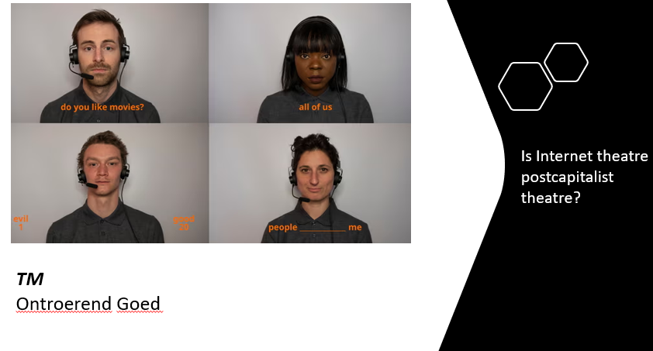

Internet theatre acts as an aesthetic shock that makes the convergence of corporeality and virtuality, that which we experience as the real today, visible as performance.
The Internet becomes a theatre when it reconfigures the audience’s perceptions of themselves from fleshy humans into digital subjects, hybrid entities that are components of our ubiquitous information ecology where all elements exist in a permanent state of interconnectivity.
Internet theatre enables us to see how the real is closer to a concept of bio-techno-hybridity within what Gabriella Giannachi calls the Archives 4.0 information environment. The ubiquitous level of connectivity engendered by this environment structures interrelations between humans, machines and data.
The nature of the Internet means these interrelations are instantaneously documented for re-interpretation by others online.
Internet theatre represent a kind of performance document recording the experience of living online during the pandemic.
The bio-techno hybridity we experience as digital humans is turning the experience of the real into something far more fluid than the materialist future.

