Fat Fists Fisting Fat:
An Excessive Queer Performance Manifisto

I am typing this with my big fat fingers. With my fat fingers, I used to hide in the sleeves of my jumpers or my pockets for photographs. My fat fingers that the school nurse once panicked were all broken as they are swollen with fat. My fat fingers that mean I never find rings that fit and that exceed standard ring mandrels. With my fat fingers where my knuckles are buried deep inside them. With my fat fingers that I began to love when I realised I had ten fat dicks on my fat hands attached to my fat wrists. I am typing this with my big fucking fat fingered fingering fat fisted fisting energy.

The queer desire manifest in fisting is one of excess. The bigger, the better. The more you have to stuff in, the greater the satisfaction. It is a realm where being too much is the goal, where space is claimed by the body, for your body and someone else’s body. It is an act where being more and expanding to fit that abundance is an exerted process of acceptance, celebration, and exaltation. To exist in my fat body, with excesses of flesh that invites constant collaborative imaginings, is for me to always be in negotiation with space and time in queer, non-normative configurations.

Fisting refers to the act of inserting most or all of the hand into a vagina or most or all of the hand and potentially including the forearm into the anus. Anything more than four fingers counts as fisting – whether or not the shape is considered to be ‘a fist.’ It has also been called ‘handballing’ or just ‘fist-fucking’. Gayle Rubin’s study of The Catacombs, ‘A Temple of the Butthole’, is a first-hand account from her BDSM fat butch dyke perspective that was published in 1991 and remains one of the most in-depth scholarly studies of fisting practice (2012, p.224-240). The Catacombs was a ‘fister’s paradise,’ a San Francisco club which opened in 1975 and quickly became famous for its invite-only ‘fist-fucking parties’ attracting people to make a pilgrimage from all over the US to participate (Rubin, 2015, p.226). In just one excessive element of the act, it is recorded that at the Catacombs, on an average Saturday night, nearly forty pounds of the lubricant Crisco, 300 towels and 2,000 gallons of water would be used.

Rubin values fisting for how it connects and creates community through intense, intimate encounters that embrace pleasure as a primary goal. Many queer theorists have noted that by its typical focus on the anus, as a sexual act it does not require any particular kind of ‘sexed’ body, or gender presentation, or sexual preference beyond its own desire – a desire turned away from ‘genitalia,’ one that displaces supposedly timeless moral standards, rejects binaries and disorients gender roles. Paul Preciado writes in his Countersexual Manifesto:
The anus’s task is not directed toward reproduction, nor is it founded on the establishment of a romantic nexus. It generates profits that cannot be accounted for in a heterocentric economy. Through the anus, the traditional sex/gender representation system shits itself [emphasis in original] (2018, p.30).

This focus on the anus is an inherent challenge to heteronormativity. Furthermore, the queer pleasure produced through fisting has always found the practice at odds with Right-wing morality campaigns, which, as Rubin notes, have been able to ‘establish state policies, social practices, and deeply entrenched ideologies which still affect the shape of our sexual experience and our ability to think about it’ (2012, p.111). These same ‘moralists’ are the ones who campaign against fat people and have entrenched fatphobia in the dominant discourse. To be fat, to give and receive pleasure in a fat body, and to revel in this abundance beyond heteronormativity, beyond slenderness, beyond bodily boundaries is to stretch towards a practice of excessive communion.

Experiencing the fat fist might not be to your own personal fat sexual preferences, but relishing the debauchery of the fat fist fisting, and particularly the fat fists fisting fat, is available to all of us through its representation and action in performance. And so, I offer each of you five of my fat fingers, one by one, to create a fat fist pointing and clenching at artists whose fists have moved me deeply, inside.
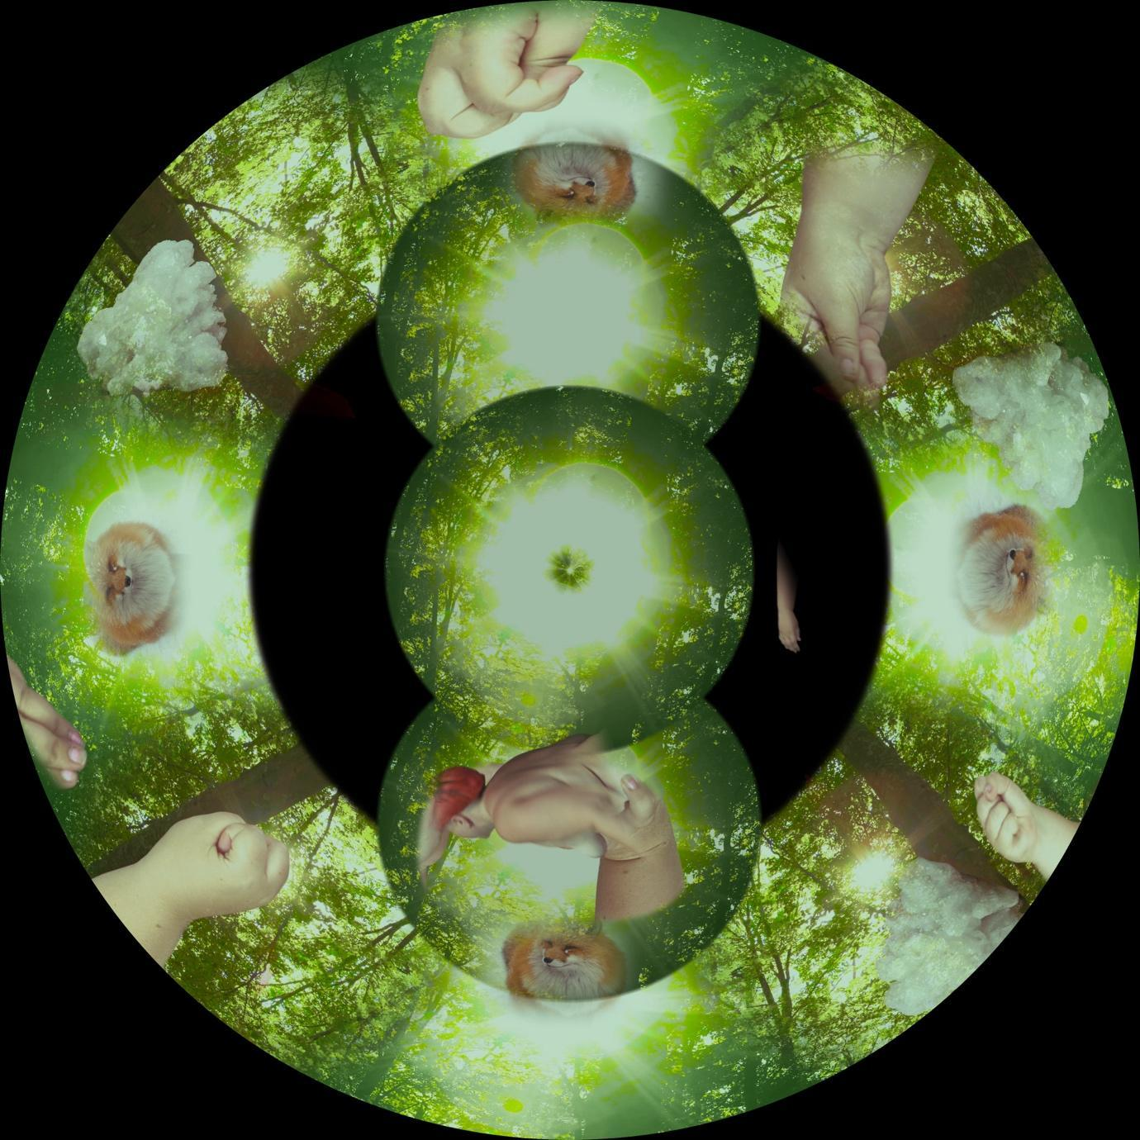
Image: Film Still, White Sands Crystal Foxes, Liz Rosenfeld (2022)
Image description: A circular ring on a black background shows a green, sunlit forest with multiple overlaid fists of a fat, white person, foxes heads and white crystals. Three overlapping circles in the central show the same green leaf canopy, the lowest one has a collaged overlay of a naked fat white body from behind, a fist and a fox.

FIRST FINGER: Liz Rosenfeld – White Sands Crystal Foxes (2022) & The Shimmer (n.d.)

My fat fist emerges like a giant’s from the edge of the screen, dominating the whole sky, and inserting itself into spinning images of leaf canopies, gently easing itself back and forth. On the other side, my colossal fingers, pressed together with my thumb tucked in (to allow a gentle easing inside), rhythmically swivel to stimulate dappled sunlight. Liz Rosenfeld’s voiceover softly intonates:
A hole is a hole is a hole is a hole is a hole is a hole…
In our hole
Thinking about the world reforming outside
Without us
All the tension
All the beauty
Because nature doesn’t need us to thrive
In fact
It needs us to be in service
Relinquish…

My fat body appears as the only human form in Rosenfeld’s film White Sands Crystal Foxes, shot predominantly in 360 degrees to be screened on huge domed planetarium screens which stretch around the heads of the audience to envelop them. Watching the premiere in Berlin in February 2022, I had an intense auto-erotic experience. Seeing myself at monstrous size, a huge, fat, ecstatic body occupying a screen designed to hold the universe at scale, as stelliform, was transcendent. Relinquishing myself to Rosenfeld’s gaze as the artist, director and co-editor had shaped and re-shaped me into a consensual object of absolute generative pleasure and desire, where my character is charged through erogenous exchanges with kaleidoscopic nature and apocalyptic landscapes.
Rosenfeld is a fat queer artist who works across forms including writing, drawing, performance, dance, film and installation. Their work ‘approaches flesh as a non-binary collaborative material, specifically focusing on the potentiality of physical abundance and excess, approaching questions regarding the responsibility and privilege of taking up space’ (Rosenfeld, 2022a). Their body of work frequently engages with holes ‘as portals, pores, thresholds and physical manifestations of un-fillable desire,’ asking ‘how do bodies submit to different kinds of holes?’ (Rosenfeld, 2022b) Rosenfeld conceives of the planetarium as a hole, a cruising space where bodies meet together inside a structure which encourages an encounter with desire.
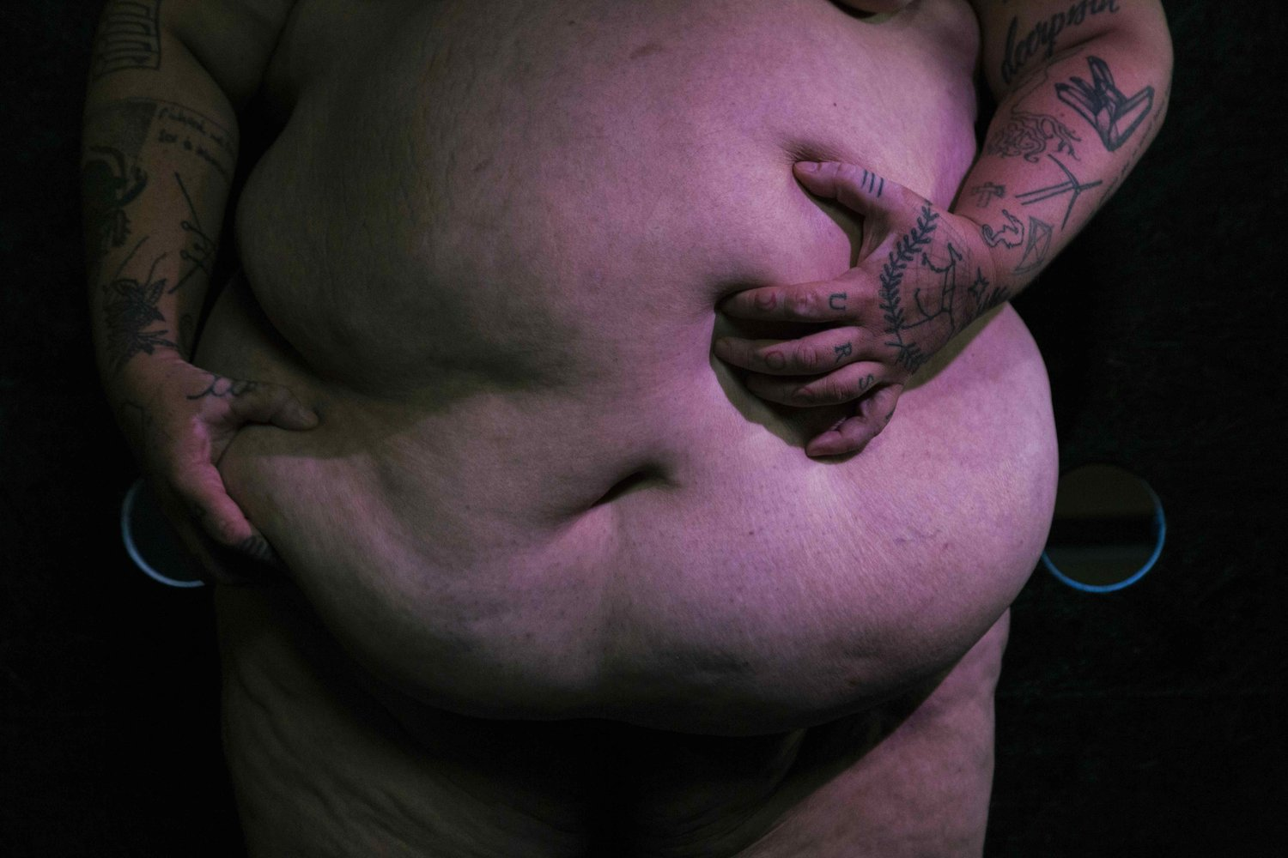
Image : Liz Rosenfeld, Tremble, 2020 (photo credit: Christa Holka)
Image description: The large, fat belly of a naked white performer is squeezed by two heavily tattooed hands on either side against a black background.
In the text The Shimmer, Rosenfeld offers ‘a fist full of flesh’ (Rosenfeld, n.d.) Performed for the premiere of White Sands under a spinning mirror ball, this scene also appears in their movement-based work I Live In A House With A Door (2019— time of writing). Rosenfeld defines The Shimmer as ‘a prism, but instead of refracting light, it refracts flesh, DNA. It mutates all life forms in ways that humans can only interpret as impossible.’ It appears to them as ‘a sparkling duvet of light. A multiplicity of genders. Like my own flesh, they are a material.’ This is an assemblage of flesh with light and motion.
I watched Rosenfeld perform I Live In A House With a Door at Toynbee Studios, London, in 2019, as one of their softly pulsating fists raised into the air. The other fist reached behind them, rotating. Fists are thrust sideways, back, up, and across their body with tension, purpose and concentration. Palms then straighten, pressing. The pleasure is manifest. The air at the ends of the fists pushed back, their shoulders contorted with the effort of the pressure, and the spine twisted. Each jerk repeated faster and faster. Rosenfeld swaggers across the stage, releasing the whole of their belly over the waistband of the black shorts. Momentarily they softly hold and then drop their belly, its weight swinging downwards. Small hip propulsions maintain the belly’s momentum as Rosenfeld circles the stage in a pendulous duet between their body and their belly – which they have identified as their ‘third genital’ (Rosenfeld, 2019, p.14). Rapture spreads over their face with such intensity that it appears like a break in their composition and their eyes meet a figure in the audience. Re-watching the documentation of this moment, my own breath is shallow — I fantasise that it is me trapped in the gaze. A trembling kinesis.
These moments created between Rosenfeld’s body and mine began my examination with fat fists fisting. An invocation of the literal, bodily pleasures that can be created through the collisions of fat flesh, knuckles, filed nails, and wanting holes. But beyond that: the generative power of bringing these fisting queer gestures into fat artistic expression to share the abundance of erotic potency that can be held inside a bulging fist.
SECOND FINGER: Homosexual Death Drive – Temple of the Butthole (2013)

“I’m sliding my hand inside you, I have my whole fist in your cunt”
– Cherry, Charlotte Cooper (2002, p.50).

It is academic adventures of fisting and shit that are the inspiration for Homosexual Death Drive’s (HDD) song and music video Temple of the Butthole. This DIY song, coupled with a home movie performance to video, typifies HDD’s approach to artmaking which is irreverent, hilarious and horribly grotesque. The connection between Kay Hyatt and Charlotte Cooper as collaborators and lovers manifests in the work’s elation where they create something that grotesquely portrays fat queer love through a fatuous similitude of fat queer sex. HDD offers a transgressive balance of lust and threat in all their work, summarised in their Theme (2014) song in which they sing: ‘first we fuck you / then we kill you / then we eat you / then we shit you.’

HDD co-founders Cooper and Hyatt take seriously, in a silly way, Lee Edelman’s provocation in No Future: Queer Theory and the Death Drive that rather than resisting the ‘heteronormative’ equation of homosexuality with death, sterility and the anti-social – such associations should be embraced. Part of HDD’s manifesto from 2015 reads:

Homosexual Death Drive is a place for us to have feelings, to tell stories that don’t have other outlets, to speak the unspeakable, anti-social and unallowed things that we feel we have to suppress in our everyday lives.
[…]
We are trying to see what we can get away with. We want to fuck people up joyously (Homosexual Death Drive, 2015).

On her website, Cooper documents how HDD have been successful in doing this, particularly through the video for queercore anthem Temple of the Butthole which is described as ‘an evergreen staple for weirdness on the internet and frequently clocks up views’ (Cooper, n.d.)
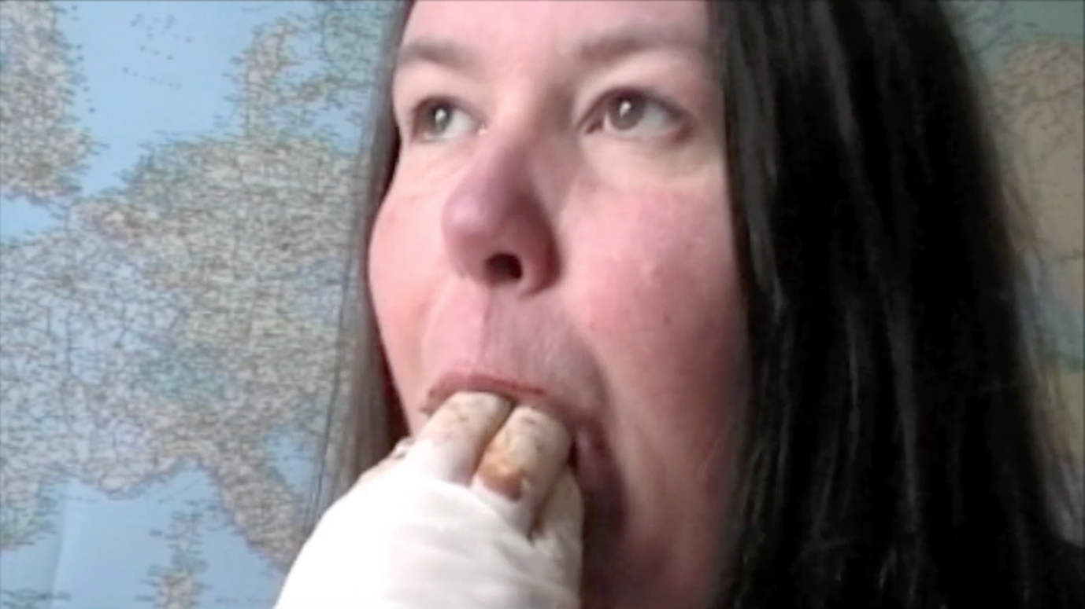
Image: Temple of the Butthole (Still from video), Homosexual Death Drive
Image description: A hand in a white latex glove, with brown stains on the fingers, is in the open mouth of a white person with long brown hair who looks up, with eyes wide open. In the background is the map of the world.

In Temple of the Butthole, Hyatt appears on a silent screen in a black balaclava in front of an atlas. A malicious grin spreads across her face as the audio of a slide whistle cuts in like a catcall. As it begins to loop and glitch, it becomes more like a siren, a warning of the naughtiness to come, as Hyatt extends her tongue in exaggerated motions. Through a fade, Hyatt is replaced by Cooper, who stares down the camera as the loops build with a mesmerising vocal chant where layers of voices create a menacing choir. Cooper, with a deadpan expression, begins to move her mouth and pursues her lips. Slowly, a stream of ‘shit’ begins to be pooped through her mouth as Cooper’s eyes glint with glee. As the excreting ends, a fat hand clad in a white latex glove enters to wipe away the remnants and prod at the pursed butthole mouth. The voices chant ‘temple of the butthole’ over and over. The finger is desperate to enter and twists and turns until it is granted permission. Cooper’s eyes swivel and bulge, then look with sultry seduction at the viewer. ‘I am the temple’ joins the chant. More fingers push their way in, emerging shit coloured between thrusts which become covered in spit and dribble brown liquid down Cooper’s chin. The thumb gains entry and the whole fist is fucking Cooper’s butthole mouth, her eyes rolling back in effort and ecstasy.

As the loops fade out, the gloved hand retreats from the scene and Cooper swiftly moves from gagging to grinning, with shit/chocolate-stained teeth revealed as she begins to laugh. The track ends and the video switches from the audio recording to the sound of Cooper and Hyatt chuckling with each other at their exploits.

THIRD FINGER: Divinity P Fudge (with Catherine Opie and others)

Inspired by Cooper’s invitation in her fat performance study guide ‘Tantalising Glimpses,’ I am scouring the archive for fat bodies. I gasped out loud when first seeing the images of Divinity P Fudge (Darryl Carlton) captured by Catherine Opie. In one he has pierced flesh dangling with hundreds of tiny chandeliers, an elegant gestural fist raising opulent iridescent purple material. In another, he stands in a Flintstones-esque leopard print two-piece and heels, hand on hip, confronting the camera with a cocked head. In yet another, he sits wide-legged, naked, with his back to Opie while Ron Athey cuts into his back – a re-staging in 2000 of the ‘human printing press’ scene from Four Scenes in a Harsh Life, a collaborative action from a show made with Athey in 1993 which was manufactured into a scandal that fuelled the flames of that decade’s Culture Wars. The Polaroids of Fudge are part of a series that featured Athey and his consistent collaborators; it shows them ‘fisting one another, cutting lines into each other’s backs, piercing one another, and so on’ (Reilly, p.85). Fat bodies abound in Ron Athey's performance troupe. Fudge is Athey’s longest performance collaboration, working together from 1992 to the present. Opie has also performed in Athey’s Deliverance (1995) and in the film Hallelujah (1998), where she whips Athey, carries him and ties him to a cross.
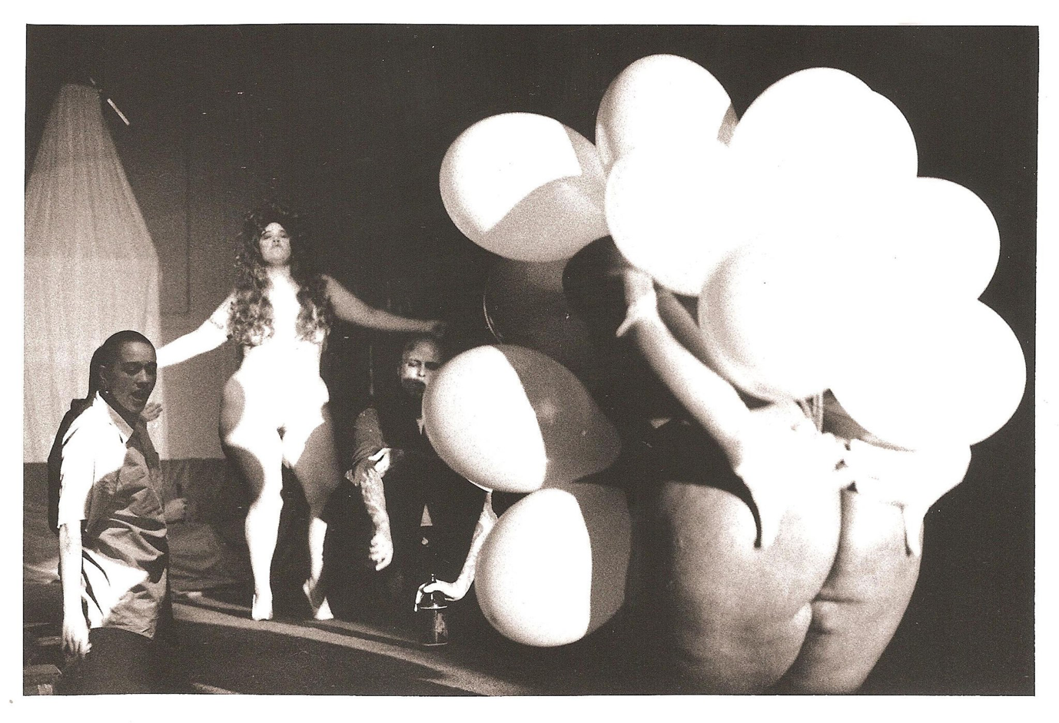
Image: Divinity P Fudge and Catherine Opie (with others) in Ron Athey, Martyrs&Saints, 4 Scenes in a Harsh Life (Ex-Teresa, Mexico City), photo by Monica Naranjo used with permission from Ron Athey.
Image description: A sepia photograph of a group of performers. On the right, Divinity P Fudge, a fat Black performer is covered with white balloons attached to his body so only his bum and hands are visible. He is bending forwards towards a group of performers including Opie, a white fat performer, who stands naked with her arms outstretched wearing a long curly wig which covers the chest.

In correspondence with Dominic Johnson, Carlton/Fudge recalls the experience of the Minneapolis showing of Four Scenes:

The feeling of accomplishment and rite of passage, the passion we all had for getting this message out, that life is truly harsh and not sugar-coated. The reality of being allowed to work with the brilliance of Ron Athey. The many nights of feeling and looking like raw meat. The healing process. The beauty of all the individuals associated with this piece. The memory of watching audience members’ faces as they watched this performance (Johnson, 2013, p.74).

Opie writes that Athey’s performances ‘are about the queer community as a whole,’ not just as a ‘language of male homosexuality, but rather as a queer language, a truly encompassing language that passes through any gender classification’ (Johnson, 2013, p.84). And as such, his troop includes all kinds of queer bodies, including fat ones, that demonstrates the beauty and sexiness of multiplicity. Cooper remembers that when she went to see Judas Cradle in 2005:

I was looking at [Amanda] Piasecki, not Athey or his co-creator Juliana Snapper. This is remarkable when you consider that Athey is a visceral performer and, in that show, ritually fucked his own arse with a giant pyramid. […] [Piasecki’s] presence as a fat performer in that show was everything to me (Cooper, 2020, n.p.)

The presence of Piasecki, Fudge, Opie and other fat performers in his onstage rituals is an inclusion, an expansion and excessive celebration of the communion of flesh, of various bodies in relation with each other in extreme ways – cutting, being cut, colliding, holding, being held open, and entering each other in joyful combinations of queerness.

Piasecki has observed that fat queer people find ‘value in inhabiting our fat bodies as freaks rather than as pretty-and-mild-as-possible apologists for our stigmatized flesh’ (quoted in Meleo-Erwin, 2012, p.395). Following her attendance at a workshop with Piasecki, academic Meleo-Erwin argued that ‘performances of freakery, or ‘gruesome,’ provide alternative understandings of social reality and help forge alternate communities and that this constitutes a micropolitics of resistance’ (Meleo-Erwin, 2012, p.396). What is particular about most current queer scholarship on fisting is that, following Rubin’s work, it focuses on the importance of fisting as a subcultural sexual practice that organises affective community and erotic relationships as intimate, transformational and transcendental experiences in almost spiritual terms. Staging queer fat bodies in complex intimacies with each other, those deemed ‘freaky’ by a cisnormative capitalist and imperialist monoculture doing ‘freaky’ things, offers a complex ambiguity and opens up a gaping hole of liminality which can be in service of subversion for a multitude of transgressive practices – destabilising the limiting expectations that are put on all bodies.

Opie shoots Fudge’s fat body from a position of similarity – she is a queer fat person who is part of S&M leather communities and includes this in her own work. I find a particular exchange of pleasure and desire in her portraits of other fat bodies such as Fudge’s to be a simmering of fat queer sexual energies. Opie has ‘vast’ tattooed on her right forearm in large capital letters. Like Fudge, her most famous works have engaged with penetration via cutting. In ‘Self-Portrait/Pervert’ (1994) she sits topless in a black leather gimp mask with the word pervert cut into her chest and more than twenty needles piercing the skin down each of her arms. The Guggenheim writes that these images offer ‘something deeply personal, even confessional, revealing powerful longings that are compounded by the great physical vulnerability of the sadomasochistic acts the photographs document’ (Guggenheim, n.d.). Like Rubin, Opie is documenting her own queer leather subculture. Her images, like Athey’s performances, offer a profound insight into a shared set of queer practices, ones that are transgressive and exhibit the vast possibilities of displaying the erotic power of extraordinarily fat sexy bodies.

FOURTH FINGER: Gertrude Stein

‘It is dangerous to be fat. Dangerous to whom not dangerous to the fat.’
- Coal and Wood, Gertrude Stein (1920).
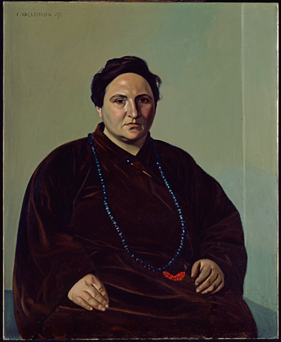

Rosenfeld’s repetition of ‘a hole is a hole is a hole,’ in both White Sands Crystal Foxes and I Live in A House With a Door replicates the famous phrase of another butch Jewish queer Gertrude Stein and the line repeated in her various works ‘a rose is a rose is a rose is a rose.’ Stein first includes this line in her highly erotic cruising poem Sacred Emily written in 1913 in which she explores the joys of ‘excessively illegitimate’ sexual practices, including ‘pussy pussy what what’ and meets myriad sexual players beyond her life-partner Alice B. Toklas including: Ethel, Susie, Anna, Willie, Henry and Lizzie. As documented in The Autobiography of Alice B. Toklas, ‘a rose is a rose is a…’ was also circled on their dinner plates, inscribed on their letter paper, on the table linen and ‘anywhere else [Stein] would permit that I put it’ (Stein, 2019 [1933], p.128) The importance of carving the circling ring of roses to their collective intimate and poetic life meant it even appeared above their bed. It is easy to imagine Alice raising Gertrude’s belly to first caress gently and then to gradually insert her whole fist into the red softness of her lover’s opening. The ring of roses is also a hole. As Stein implores in her, A Long Gay Book:

Pin a little pin inside each muff, show the slant that should expose a foot, serve the same thing that has seen enough, love the moment best which is all bliss. A mighty circle and a clean retreat, a master piece and any fist you please, all this and collusion, was there ever a sign (Stein, 1996 [1933], p.249).

The ‘bliss’ of a ‘mighty circle’ provided by ‘any fist’ and perhaps, any foot, holds the coded world of queer sex. The use of the word ‘gay’ in the title itself was then a coded reference to queerness, which she had used and played with since Miss Furr & Miss Skeene (1922), a story which describes a lesbian relationship and is the first known printed reference to ‘gay’ meaning homosexual as well as its more culturally dominant meaning of happy and carefree.

One of the most intensely lascivious appearances of roses being roses is in Lifting Belly, Stein’s exploration of the joy of sexual encounters with fat bodies and more specifically her own fat body:

Why can lifting belly please me.
Lifting belly can please me because it is an occupation I enjoy.
Rose is a rose is a rose is a rose.
In print on top.
[…]
Lifting belly is perfect.
Do you stretch farther.
Come eat it.
What did I say. (Stein, 2020 [1915-7], p.21).

From its initial publication, reviews recognized the poem as ‘openly’ and ‘luridly’ exploring ‘physical passion’, celebrating it for its explicitness. A foreword remarks:

Lifting belly is not lesbian sex, over there in the closet, hidden away from the public eye. Lifting belly is lesbian sex in the world, participating, relating and transforming everything it encounters (Mark printed in Stein, 1995, p.xix).

However, what is not noted in any published analyses of this work is the ‘tender, fierce and tender’ interaction with the belly itself (Stein, 2020, p.5). The effusive possibilities of lifting a large belly, exploring its landscape (the way it looks, feels, tastes, smells), searching through what it holds inside, underneath and being aroused through the power felt through the weight it offers. Stein describes herself as the geologic sex object “Mount Fatty” to be conquered:

Feel me.
I feel you.
[…]
What can you say.
I can say there is no need of regretting a ball.
Mount Fatty.
[…]
And then there was a cake. Please give it to me.
She did (Ibid, p.21).

I slide into the DMs of Sophie Robinson, the queer poet, when she shares an Instagram story of Lifting Belly to tell her I am writing about it at the moment. She asks me if I know that ‘Mount Fatty’ became a pet name for Stein after it was repeated so often to Toklas as an instruction. I reply with the hot face emoji and fingers pinched upwards in a chef’s kiss.

THUMB: Anohni – Fistful of Love (1994/2005)

Given the entanglement between pleasure, queerness and fatness, I would argue it is not a coincidence that the two best songs about fisting come from queer fat icons. Although Temple of the Butthole and Fistful of Love share little in terms of their production budgets, they are both anthems for the complex tensions of erotic bodily pleasure. Fistful of Love, track seven on Anohni and the Johnson’s I Am A Bird Now (2005), is a song of such total unbridled joy and desire it physically unlocks and releases my body, always leading to tears flowing over a grin. As musicologist Ross Cole observes

When we hear a song it also seems to hear us. As we enter the world of a song, allowing it to infringe momentarily on our consciousness, we yield and the song begins to lead us – perhaps unwillingly, perhaps unwittingly – down unexpected pathways bent in the undergrowth of reminiscence and imagination (Cole, 2021, p.81).

In listening, I yield to Anohni and the erotic world she produces. I am inside the recording, inside a large room with a party of musicians, in a lavish celebration of bottoming in a sadomasochistic exchange – ‘I accept and I collect upon my body / The memories of your devotion.’ The fist is offered and received ‘out of love,’ not in a conventional heteronormative expectation of an exchange of power and fidelity, but in the abundance of sexual pleasure that is generated through total bodily surrender.

Anohni’s work as an artist and singer-songwriter is drenched in queerness and an unrelenting concern with contemporary political conditions. I Am A Bird Now as an album title at once a statement of Anohni’s transgender identity, crassly using their native British slang to state “I am a bird now” and an orphic exploration of transformation and transcendental escape symbolised by birds. As Dee Heddon argues, the subjectivity confessed in autobiographically informed work holds the possibility for transformation which has utopian potential – particularly for those whose stories or identities are marginalised or oppressed by dominant culture. Heddon writes that these works ‘represent the already lived in order to beckon us towards, urge us to imagine, or compel us to create the yet to be lived’ (2006, p.171). A desire for, and evidence of, shifting embodiment plays out tracks which begin concerned and mournful with I Hope There’s Someone (“I hope there’s someone to take care of me, when I die…”) but slowly turn into hopeful, tender tracks towards Free at Last, the Spiritual song performed by Julia Yasuda. A photo of transgender icon Candy Darling on her deathbed, taken by Peter Hujar, speaks to these themes of beauty, care and death. ‘The Johnsons’ of the band’s name is a reference to Martha P. Johnson, the legendary queer activist who fought at Stonewall and established STAR (Street Transvestite Action Revolutionaries) to support homeless LGBT youth and sex workers. The shared history of queer and trans lives is written through Anohni’s work and performance – although these iconographies and codes were often missed or passed over as the album gained mainstream success. Similarly, Fistful of Love’s queer codes have been missed or passed over; the heteronormative reading is only able to connect fists with violence.

Fistful of Love was written for the Blacklips show of the same name, performed on 4 November 1994. Blacklips was a legendary subcultural queer performance group co-founded in the midst of the AIDS crisis by Anohni with Johanna Constantine and Psychotic Eve, who took up a weekly Monday 1 am slot at The Pyramid Club in Manhattan to perform a brand new ‘play’ from June 1992 until March 1995. The poster for the performance of Fistful of Love featured a black and white photocopied image of renowned photographer Robert Mapplethorpe, who made many exquisite images of gay men fisting and being fisted. Benjamin Titera described Blacklips as ‘a para-theatrical art collective: part cabaret, part death-disco, part psychodrama, part gore fest, part endurance test, part ceremony, part femme feast’ with a core collective of thirteen members but including upwards of twenty participants who were ‘artists, drag queens, punk women, alienated queers, and veterans of previous late-night scenes in the East Village’ (Titera with Anohni, 2023, n.p.) Anohni described Blacklips work:

The audience was pelted with buckets full of blood and guts, knives, sperm, jewels, drugs, shit and love. Players pasted the many hues of filth to their lips and eyelids and pinned sparkling golden maggots to their lapels. Sets were jerry-rigged together from Blacklips’ hoard of trash pickings: broken wheels, twisted metal, dismembered dolls, pudding-filled chamber pots, tinsel glitz and cottonballs, spindles of gutted umberellas, piss-drenched Christmas trees, and later the sheets of lurid red silk, stained with splattering of last week’s entrails… (Ibid, n.p.)

The song’s early life as embedded in this messy queer collectivity, drenched in bodily fluids and part of a vital countercultural scene, is only preserved in part as it transfers, over a decade later, into the recording on the award-winning album.

In live versions, the ecstasy of the song and the experience pour from Anohni’s face and through her fat fingers as they strike the piano keys. In one recording from 3 February 2009, recorded at The Sixth and I Synagogue in Washington D.C., she adlibs with glee through a sweet smile ‘I accept the nature of this love,’ before continuing to sing, caressing her chest gently and rocking with elation. The arrangement relies on an expansion and contraction of tension – held in live shows by the strings and supported by a jubilant brass section in the studio recording. Her blissful, emotive voice always floating across the top. This is underpinned by a stark, tense, staccato metronomic drum beat, played by Parker Kindred, which on the album track has an unexpected yet regular accent on the eight beat that throws the listener forward. This hints at the strikes of ‘the whip’ supported by the punctuation of Lou Reed’s guitar, which is forcefully strummed with increasing intensity that alternates with crunches and cracking, with flatline feedback, in metal machine harmony which imbues the work with an unsettling, energetic frisson. As Anohni builds from ‘I feel your burning eyes / burning holes’ the sonic fervour bursts forth as her voice in rhythmic unison with the whole band pounding the line ‘straight to my heart.’ Weaving its way through queer inferences and references but always hurtling towards this orgasmic release, everything inside Anohni and inside me pours out and begins to tumble and spiral. Musical ecstasy invokes the transcendence of losing your body and mind in the excesses of gratification.

Give me a little fistful of love
Give me a little fistful of love
Fistful of love
Fistful, fist, fist, fistful of love

Fancy A Double Fist?

Taking pleasure in both fisting and fatness is considered, in turn, dangerous, extreme, excessive, thrilling, life-threatening, abnormal, loving, shocking, disgusting, awe-inspiring, taboo, reviling, exciting, and highly transgressive. Medical journal articles on fisting are full of scaremongering about its risks, pathologizing its practitioners and coldly concluding that such a decadent act falls outside anything that could be seen as reasonable to do to oneself or another. Fisting is still obscene, offending a heteronormative social consensus about what bodies can and should do. Its representation, practice or invocation in queer art, music, performance and literature adds a frisson of disobedience, secret worlds, hidden intimacies, alternative possibilities and potentialities of existence beyond the reasonable, mundane or ordinary. The promise of visceral pleasure you can only enter into by exceeding what is expected of you and with a spirit of trespass. I am reminded that pleasure is not something handed to us as fat people via acceptance or legitimacy but something we can generate in the palm of our own hands for ourselves and for each other.

As I begin to peel my XL latex glove away from my fat fingers, which are dripping lube all over my keyboard as I type, you may feel like you have have been filled up with these revelations of fat queer excessive actions, and it still is not enough. You could take more. Preparing my manicure on my second hand, I might point you first towards taking poppers while being held in the soft and vast bosom of Katy Baird (Poppers Boudoir, 2017); secondly, stuffing Nao Bustamente’s burrito strap-on dildo-cum-fist down your throat in Indigurrito (1992); thirdly, acquiescing to alien tentacles becoming squirming fists in the written orgies of Tamm Reynolds as Midgitte Bardot (Untitled, 2021 - time of writing ); fourthly, if the tentacles were not enough, perhaps a giant lobster claw (a crustacean fist) fucking Divine (as ‘Lady Divine’) in Multiple Maniacs (John Waters, 1970) will satiate you; and fifthly, a final fat thumb clenches and releases streams of blood onto a pristine white runway on which walks Franko B (I Miss You, 2003). The excessive is desired, and so are you.

References:

Cole, R. (2021) ‘Popular Song and the Poetics of Experience,’ in Journal of the Royal Musical Association. 146(1), pp.81–106.

Cooper, C. (2020) Tantalising Glimpses: A LADA Study Room Guide on Fat. LADA.

Guggenheim (n.d.) Catherine Opie: Self-Portrait/Pervert. Available at: https://www.guggenheim.org/artwork/12201.

Heddon, D. (2006) ‘Beyond the Self: Autobiography as Dialogue,’ in Wallace, C. (ed.) Monologues: Theatre, Performance, Subjectivity. Litteraria Pragensia, pp.157-184.

Homosexual Death Drive (2015) Homosexual Death Drive Manifesto. Available at: http://www.charlottecooper.net/homosexualdeathdrive/works/antisocial/

Johnson, D. (2013) Pleading in the Blood: The Art and Performances of Ron Athey. Intellect.

Mark, R. (1995) ‘Introduction,’ in Stein, G. Lifting Belly. The Naiad Press, pp. i-xxx.

Meleo-Erwin, Z. (2012) ‘Disrupting Normal: Toward the ‘ordinary and familiar’ in fat politics,’ Feminism & Psychology, 22(2), pp.388–402.

Preciado, P. B. (2019) The Countersexual Manifesto [2011]. Translated by Kevin Gerry Dunn. Columbia University Press.

Reilly, M. and Opie, C. (2001) ‘The Drive to Describe: Interview with Catherine Opie,’ Art Journal.

Rosenfeld, L. (2019) ‘Luxurious Tissue, Silky Sweat: Moving in Unreasonable Time,’ Tanzraumberlin (July/August).

Rosenfeld, L. (2022a) ‘Profile: Liz Rosenfeld,’ Tohu Magazine. Available at: https://tohumagazine.com/profile/liz-rosenfeld.

Rosenfeld, L. and O’Brien, A. (2022b) ‘Film as Flesh: An Interview with Liz Rosenfeld,’ Berlin Art Link (4 Feb). Available at: https://www.berlinartlink.com/2022/02/04/liz-rosenfeld-interview-berlinale-2022-forum-expanded/

Rosenfeld, L. (n.d.) The Shimmer. Unpublished.

Rubin, G. (2011) Deviations: A Gayle Rubin Reader. Duke University Press.

Stein, G. (1996) ‘A Long Gay Book’ [1932], in Dydo, U.E. A Stein Reader. Northwestern University Press, pp. 152–253.

Stein, G. (2019) The Autobiography of Alice B. Toklas [1933]. Ryerson Pressbooks.

Stein, G (2020) Lifting Belly [1933]. Counterpoint.

Titera, B. and Anohni (2023) ‘Bloodbags and Beauty at the End of the Millenium,’ in Anohni and Wilkerson, M. (eds.) Blacklips: Her Life and Many, Many Deaths. Anthology Editions.

For more on HDD and sterility see Theme (2014) which includes Cooper singing: ‘when I was a little girl, I promised myself that I would never be a mother, I would never give birth, I would always choose abortion, and now I can’t wait for menopause, I am proud to be barren, nothing will ever come from my cunt but cum.’
As a historical ‘bad gay,’ considering Gertrude Stein’s biography might remind us that liberal approaches to sexuality and avant-garde artistic inclinations do not always equal liberated politics. There has been some academic debate around the extent of Gertrude Stein’s collaboration with the French Vichy Government while she and Alice Toklas (both Jewish lesbians) survived World War II in France and there is an overview here: https://lareviewofbooks.org/article/was-gertrude-stein-a-collaborator/.
Liz Rosenfeld reflects on their Jewish roots and identity and what it meant for them to move to Berlin in this series of works: https://www.goethe.de/ins/gb/en/kul/mag/21139886.html.
The album was the second released under the band’s original name ‘Anthony and the Johnson’s’ before Anohni changed her name, and the band was also renamed.
Although Anohni identified as transgender from an early age, her genderqueer expression and declarations of being transgender were not acknowledged in mainstream press about her until she changed her name publicly in 2016.

